BMKT011
Strategic Digital Advertising Rationale Report for Moon Pad Sleep-optimised Speaker

A4: Marketing Communication Strategy: Rationale Report
Jiashang Cao
23124343
1059 Words

Content
1.0 Advertisement Objective 1
2.0 Explanation of Advert Appeal to Target Audience 1
2.1 Appeal Selection 1
2.2 Colours Selection 1
2.3 Images Selection 2
2.4 Layout Selection 3
3.0 AIDA Model Cues 3
3.1 Cues for Attention 3
3.2 Cues for Interest 5
3.3 Cues for Desire 5
3.4 Cues for Action 6
4.0 Ethical Consideration 7
5.0 Digital Medium Selection 7
References 9

1.0 Advertisement Objective
The strategic digital advertising campaign aims to ​​trigger immediate purchasing behavior​​ for Moon Pad sleep-optimised speaker among Australian parenting demographics aged 30-45 by ​​activating fear of long-term sleep deprivation risks​​ to physical and mental health while reinforcing the brand’s ​​societal responsibility commitments​​.

2.0 Explanation of Advert Appeal to Target Audience

2.1 Appeal Selection
The advertisement adopts a fear appeal strategy. It first presents the consequence of "sleep deprivation turning life into chaos" caused by infants' noise, arousing parenting parents' concerns about health risks and creating a strong sense of urgency. The video then naturally transitions to a tranquil scene, showcasing the Moon Pad product alongside “Weightless” as a clear solution that alleviates fear through music. This "fear activation-solution provision" model harnesses the driving force of fear while eliminating psychological resistance through the product's tangible functions, strongly motivating audiences to adopt the offered solution (Kang & Lin, 2015).

2.2 Colours Selection
In the opening scene, a black background with white text creates urgency and solemnity, simulating the chaos of late-night scenes. Lichtlé (2007) states that high-contrast colors like black and white are more physiologically stimulating than low-contrast palettes, better triggering emotional responses in the audience.

Next, in subsequent scenes, soft blue becomes the dominant tone. In psychological research (kredibanka.org, 2021), blue represents tranquility and relaxation, contrasting with the earlier dark environment to symbolize the transition from chaos to peace.
Figure 1
Blue-color-meaning-symbolism-infographic
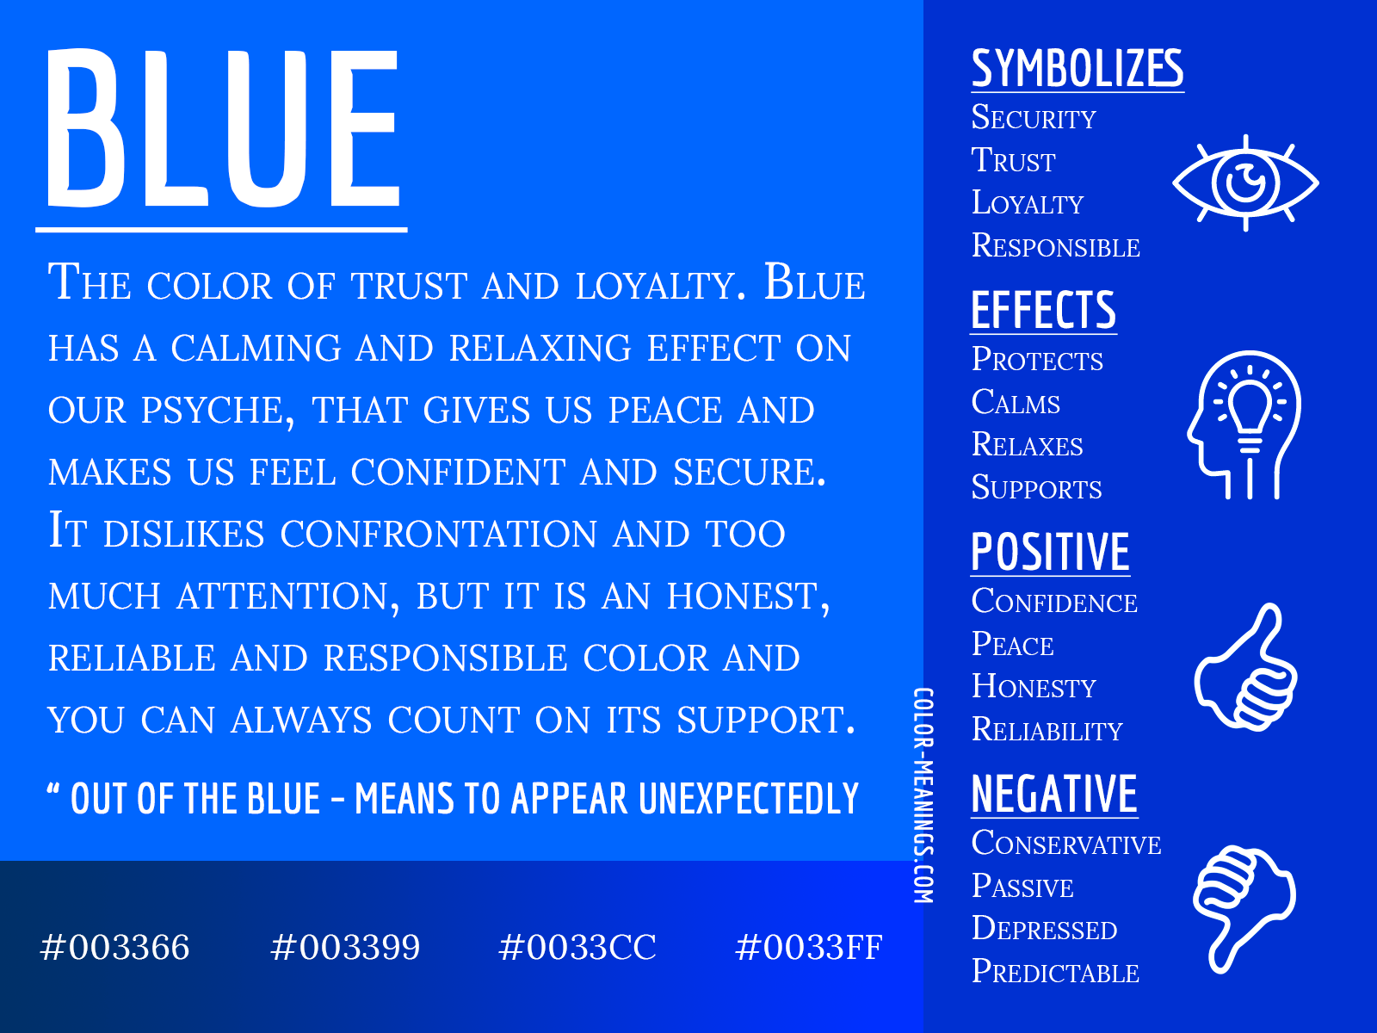
(Source: kredibanka.org, 2021)

2.3 Images Selection
The sight of a crying baby immediately resonates with parents. The image of a weeping infant intensifies parents' emotional conflict, making a deeper impression (KAKUMORI & YAMAGUCHI, 2012). Then, showing an exhausted father with messy hair and dark circles under their eyes boosts relatability, reflecting the parents’ sleep deprivation in Australia.
In the subsequent scenes, a close-up of the Moon Pad product is shown, highlighting its ultra-thin design and fabric material. This verifies the physical details of the product and enhances the trust in its efficacy. Immediately after, the same father appears again to enhance the visual impact, demonstrating the high-quality sleep the father enjoys after using the Moon Pad product. The final moon-shaped logo and the "Come and experience it now" call-to-action use size and colour contrast to prompt customers to make an immediate purchase.

2.4 Layout Selection
The advertisement uses a clean layout to spotlight the product's key info, with a 16:9 video ratio. Most English text will be in size 122, centered for emphasis. Central prompts can quicken response times in target detection and strengthen visual unity (Posner, 1980). Our minimalist ad format suits fast-paced info-consumption habits, helping anxious parents grasp the essentials rapidly. This enhances ad appeal and info-delivery efficiency. Also, the font style shifts from sharp to rounded with changes in background audio, underscoring Moon Pad as a sleep solution.

3.0 AIDA Model Cues

3.1 Cues for Attention
This stage rapidly captures the audience's attention through multi-sensory stimuli. Auditory, the universal stress trigger of infant cries is employed, paired with eye-catching text "trouble falling asleep". Visually, high-contrast imagery is utilised, featuring a black background and the sleepless expression of the baby, creating a strong visual impact (Own, 2025).
Figure 2
The Crying Baby
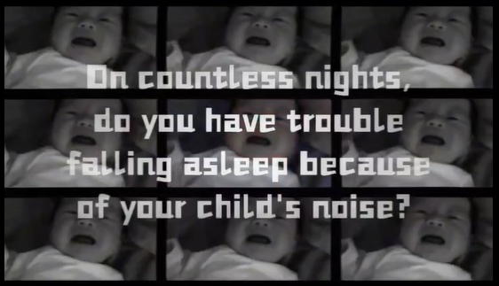
(Source: Own, 2025)

Next, it shows a father who has trouble falling asleep. Overlaid on the image is the text "Lack of sleep makes life chaotic" in white font (Own, 2025). It emphasises the negative impact of insufficient sleep on one's life, suggesting that sleep deprivation due to the baby can lead to disorder and turmoil.
Figure 3
A Father Who Has Trouble Falling Asleep
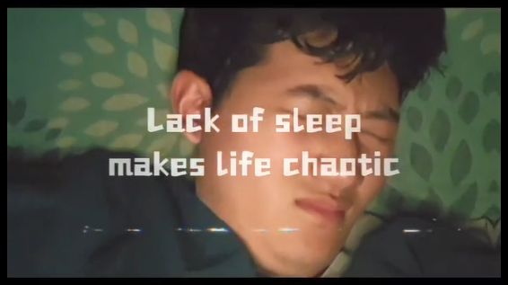
(Source: Own, 2025)

3.2 Cues for Interest
In this phase, consumer interest is piqued through product demonstration and auditory transitions. The advertisement shows hands gently cradling the Moon Pad, conveying the product's texture and reliability. Additionally, the tagline "Healthy and high-quality sleep" implies that the product is endorsed by other parents (Own, 2025).
Figure 4
Show the Moon Pad Sleep-optimised Speaker
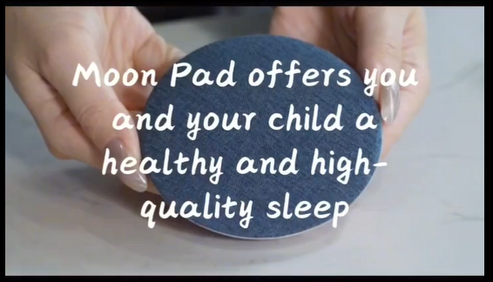
(Source: Own, 2025)
Auditory, there is a shift from the harsh cries to the soothing music "Weightless", subtly suggesting that sleep problems can be resolved. Shepherd et al. (2023) explain that Weightless reduces stress by 36%, making it an effective decompressor.

3.3 Cues for Desire
This stage evokes consumers' purchasing desire through emotional contrast and social proof. By presenting contrasting images of the same father, transitioning from a state of sleepless chaos to peaceful slumber by using the Moon Pad, a strong emotional contrast is created. Meanwhile, the text "NCE natural materials" appears, projecting the company's eco-friendly image (Own, 2025).
Figure 5
The Father Falls Asleep Peacefully with the Help of Moon Pad

(Source: Own, 2025)

3.4 Cues for Action
The final stage aims to prompt consumers to take action. A direct call-to-action (CTA) "Come and experience it now!" is used, accompanied by the brand's moon-shaped logo to enhance brand recall (Own, 2025).
Figure 6
Come and Experience it Now!
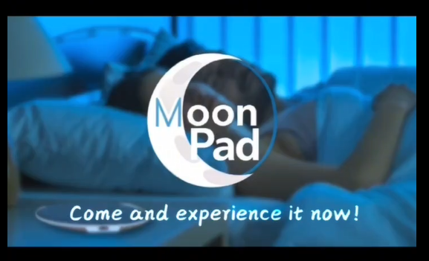
(Source: Own, 2025)

4.0 Ethical Consideration
The advertisement emphasises the use of NCE natural synthetic materials, which aligns with the ethical considerations of the concept of sustainable development. NCE materials contain 50% renewable wood pulp fibers instead of petroleum-based plastics, and they can effectively control internal sound wave reflections, reducing sound coloration (Thomas, 2013).
Figure 7
% who agree that they would pay more for eco-friendly products
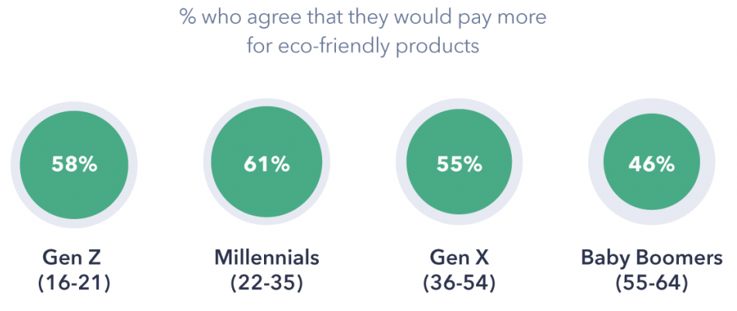
(Source: Elfrida, 2018)
As seen in the image above (Elfrida, 2018), 61% of millennials tend to support eco-friendly products in their consumption concepts and are willing to pay higher prices for them. Additionally, parents are highly sensitive to children's health. Since NCE materials are free of harmful substances such as phthalates, they meet parents' demands for safe parenting (Thomas, 2013).

5.0 Digital Medium Selection
This advertisement is best suited for Facebook.​​ Facebook's ad revenue reached ​​69.41 billion in 2022, far surpassing YouTube (15.29 billion) and Instagram ($43.28 billion), further solidifying its position as Meta's core revenue driver as seen in the figure below (eMarketer, 2022).
Figure 8
Companies With Over $10 Billion in Net Digital AD Revenues Worldwide, 2022
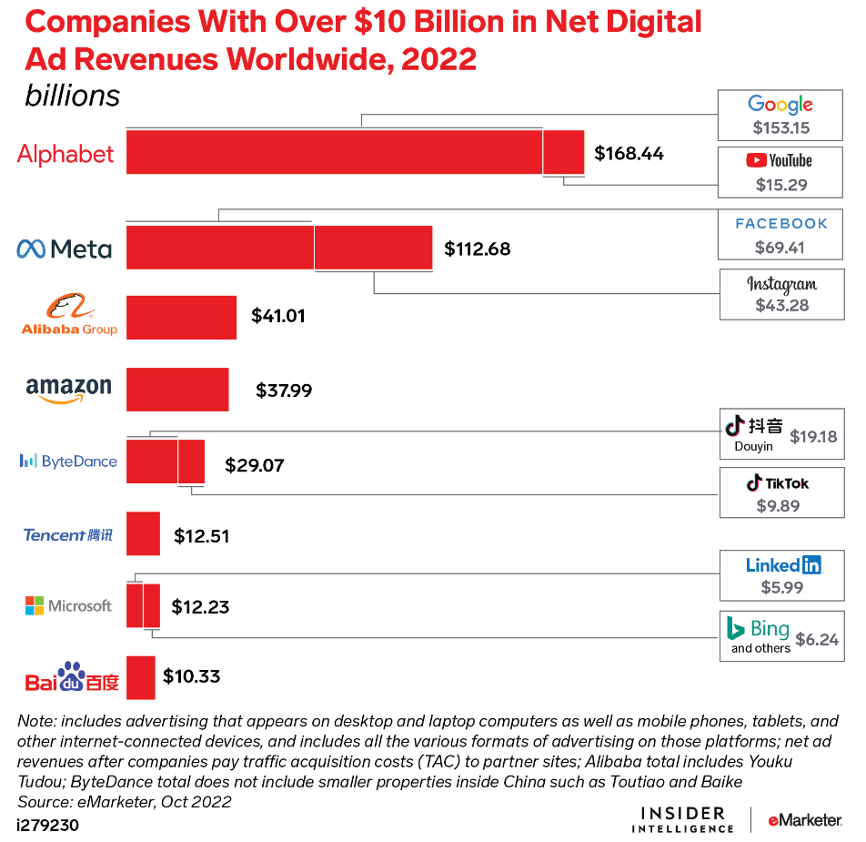
(Source: eMarketer, 2022)
Its ​​visual and text-based ads​​, combined with short-form, fast-paced social content, align well with rapid dissemination. Chen et al. (2024) show that fast rhythm consumers have a significantly higher click-through rate (2.07% vs. 1.00%) for minimalist ads over complex ones. Users exhibit high acceptance of lightweight content, making Facebook ideal for quick exposure of promotional campaigns.

References
Chen, S., Ponomarenko, V., Xiao, T., Lv, L., & Liu, G. (2024). Stop and smell the roses: How and when busyness impacts consumers’ preference for minimalist advertisements. Psychology & Marketing, 41(4), 899–915. https://doi.org/10.1002/mar.21958
Elfrida, D. (2018). % who agree that they would pay more for eco-friendly products [Infographic]. GlobalWebindex. https://joreyqtiphanie.pages.dev/rrqxqan-consumer-trend-report-2024-mhwnfip/
eMarketer. (2022). Companies With Over $10 Billion in Net Digital AD Revenues Worldwide, 2022 [Infographic]. eMarketer. https://www.emarketer.com/content/5-charts-social-media-around-world
KAKUMORI, T., & YAMAGUCHI, H. (2012). A Basic Study on Support for “Parental Power Growth” of Mothers and Fathers during Pregnancy : Through the Analysis of Interpersonal Emotion and Images of Baby’s Crying. Japanese Journal of Social Welfare, 53(3), 46–56. https://doi.org/10.24469/jssw.53.3_46
Kang, J., & Lin, C. A. (2015). Effects of Message Framing and Visual-Fear Appeals on Smoker Responses to Antismoking Ads. Journal of Health Communication, 20(6), 647–655. https://doi.org/10.1080/10810730.2015.1012242
kredibanka.org. (2021). Blue-color-meaning-symbolism-infographic [Infographic]. kredibanka.org. https://ww3.kredibanka.org/?subid1=fea8c4db-358d-11f0-9400-6c5d2e7c8876
Lichtlé, M.-C. (2007). The effect of an advertisement’s colour on emotions evoked by attitude towards the ad: The moderating role of the optimal stimulation level. International Journal of Advertising, 26(1), 37–62. https://doi.org/10.1080/02650487.2007.11072995
Posner, M. I. (1980). "Orienting of attention". Quarterly Journal of Experimental Psychology. 32(1): 3–25. https://doi.org/10.1080/00335558008248231
Shepherd, D., Hautus, M. J., Giang, E., & Landon, J. (2023). “The most relaxing song in the world”? A comparative study. Psychology of Music, 51(1), 3–15. https://doi.org/10.1177/03057356221081169
Thomas, B. (2013, August 19). SOS Magazine - An Eco-Friendly and Professional Monitoring Speaker? Sound On Sound. https://www.soundonsound.com/shop/print-magazine-back-issues/2013-print-magazines/august013-edition
Williams, S. (2022, April 12). Australian sleep statistics. Sleep Education. https://www.sleepeducation.net.au/australian-sleep-statistics/

